|  |  |  |  |  |  |  |
| --- | --- | --- | --- | --- | --- | --- |
| **Ujian Akhir Praktikum - Semester Ganjil 2020/2021**  *Practicum Final Exam –Odd Semester Year 2020/2021* | | | | | | |
| **Matakuliah**  *Subject* | | | **ISYS6169 – Database Systems** | | |  |
| **Kelas**  *Class* | **:** | **BB01 / BE01 / BC01 / BD01 / BA01** | | **Tanggal Mulai**  *Start Date* | **: 21 December 2020** |
| **Waktu Mulai**  *Start Time* | **: 13.20** |
| **Dosen**  *Lecturer* | **:** | **D1521 - Indrajani, S.Kom., M.M.**  **D1972 - Dr. Diyurman Gea, S.Kom., M.M.**  **D5295 - Lay Christian, S.Kom., M.MSI**  **D5385 - Fifilia, S.Kom., M.MSI**  **D5386 - Edi Purnomo Putra, S.Kom., M.MSI** | | **Tanggal Selesai**  *End Date* | **: 21 December 2020** |
| **Waktu Selesai**  *End Time* | **: 15:20** |

**PERATURAN UJIAN:**

*Exam Regulations:*

* Mahasiswa tidak diperbolehkan berdiskusi dan/atau bekerja sama dengan peserta ujian lainnya

*Student is not allowed to discuss and/or work together with other exam participants*

* Mahasiswa tidak diperbolehkan untuk membuka dan menyalin dari **BUKU** atau **CATATAN**, **VIDEO** dari pengajar (recording kelas, VBL, Youtube, dsb) dan **REFERENSI** lainnya

*Student isn't allowed to open and copy from any resources such as notes, videos (class recording, VBL, Youtube, etc) and other references*

* Mahasiswa tidak diperbolehkan membuka dan menyalin jawaban dari internet (google, stackoverflow, dsb)

*Student isn't allowed to open and copy answer from the internet (google, stackoverflow, etc)*

* Asisten **BERHAK** memberi nilai 0 **(NOL)** bagi peserta ujian yang melakukan segala bentuk kecurangan

*Assistant is able to give 0 (ZERO) score for exam participant who does any cheating actions*

* Kumpulkan jawaban tepat pada waktunya, apabila terlambat mengumpulkan maka jawaban tidak akan dikoreksi dan nilai mahasiswa adalah 0

*Submit the answer on time, if not, then the answer will not be checked, and the students will receive 0 (ZERO)*

* Bila Anda tidak membaca peraturan ini, maka Anda dianggap telah membaca dan menyetujuinya

*If you have missed to read these regulations, so you are considered to have read and agreed on it*

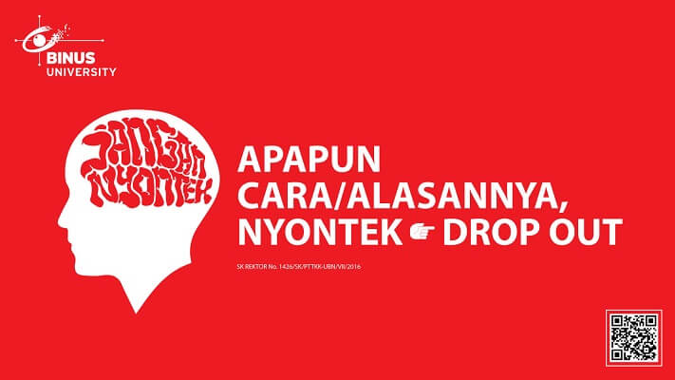

**SOFTWARE YANG DIGUNAKAN:**

*Software will be used:*

* SQL Server Management Studio 18.5.1
* SQL Server Developer 2019
* Microsoft Office 365
* Visual Paradigm Community Edition 16.1

**FILE YANG DIKUMPULKAN:**

*File must be collected:*

* SQL

**PERHATIAN!**

*Attention!*

* Bagi yang mengerjakan tidak sesuai dengan soal, maka akan diberikan nilai **NOL (0)**

*For those who do not work in accordance with the exam case will be marked as* ***ZERO (0)***

* Bagi yang mengerjakan tidak sesuai dengan software dan versi yang telah ditetapkan, maka akan tetap dikoreksi dengan software dan versi yang telah ditetapkan

*For those who do not work in accordance with the software and specific version will be corrected by the predefined software and version*

* Kompres semua jawaban yang akan diunggah. Pastikan format pengumpulan nama file dan ekstensi sesuai dengan format berikut: **[NIM]-[NAMA].zip**

*Compress all file that will be uploaded. Make sure the format for collecting file name and extension according to the following format:* ***[NIM]-[NAME].zip***

**Tabel Relasional**

*Relational Table*

**Melody Store**

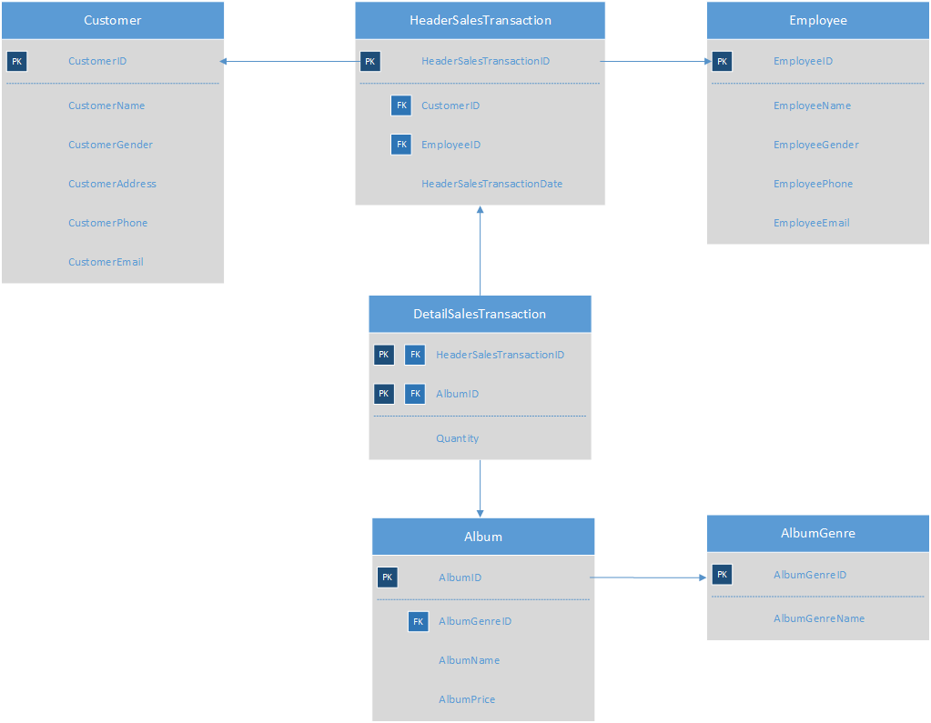

**Soal**

*Case*

1. Display **CustomerName**, **CustomerPhone**, and **CustomerEmail** for every customer whose name **does not** contains **more than one word**.

(**not like**)

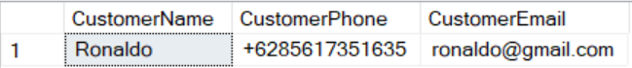

1. Display **CustomerName**, **EmployeeName**, and **HeaderSalesTransactionDate** for every transaction which occurs on **Tuesday**.

(**datename, join**)

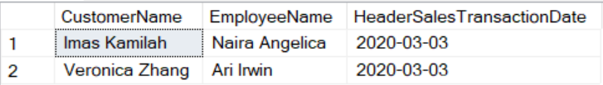

1. Display **AlbumName**, **Album Price** (obtained by adding ‘Rp’ in front of **AlbumPrice**), and **Total Album Purchased** (obtained from the **total of quantity**) for every Album which **name is more than five characters length**.

(**cast, sum, len, join, group by**)

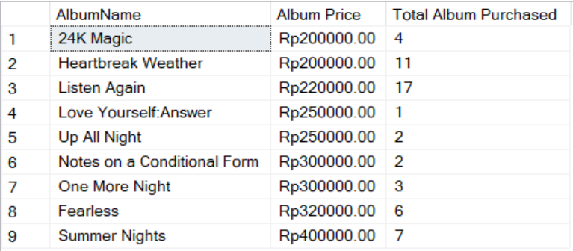

1. Display **Customer Name** (obtained by adding 'Mr. ' in front of **CustomerName**), **Total of Album Type** (obtained from the **total number of album**), **Total of Quantity** (obtained from the **total quantity**), and **HeaderSalesTransactionDate** for every Customer whose **gender is ‘Male’**. Then, **combine** with **Customer Name** (obtained by adding 'Mrs. ' in front of **CustomerName**), **Total of Album Type** (obtained from the **total number of album**), **Total of Quantity** (obtained from **total quantity**), and **HeaderSalesTransactionDate** for every Customer whose **gender is ‘Female’**. **Sort** the data based on **Total of Quantity** in **ascending** order.

(**sum, count, like, union, order by, group by**)

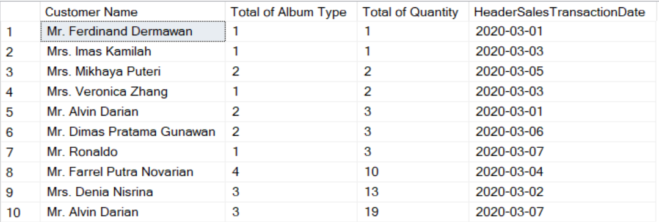

1. Display all the **Customer** data for every customer who has transaction on an **even** day of **TransactionDate** and purchase album which **name is ‘CALM’**.

(**in, day, like**)



1. Display **CustomerID**, **Customer Name** (obtained from the **first word of CustomerName**), **CustomerPhone**, and **CustomerEmail** for every customer who has **purchased more than one album**.

(**substring, charindex, count, like, alias subquery, group by**)

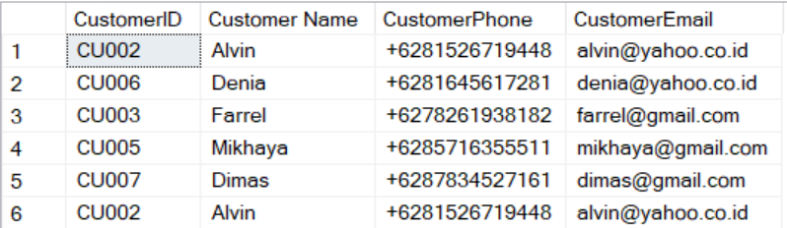

1. Create a **view** named ‘**UpdatedCustomerData**’ to display **CustomerName**, **CustomerGender**, **CustomerPhone**, and **Customer Email** (obtained by **replacing** ‘.co.id’ with .com on **CustomerEmail**) for every customer whose email contains **‘yahoo’** domain.

(**create view, replace, like**)

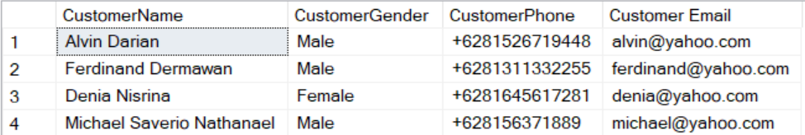

1. Create a **view** named **‘TransactionDataOfPopAlbum’** to display **HeaderSalesTransactionID**, **Day of Transaction** (obtained from day of **HeaderSalesTransactionDate**), **HeaderSalesTransactionDate**, and **Total of Quantity** (obtained from the **total of Quantity**) for every transaction which sold album that **genre** name is **‘Pop’**.

(**create view, datename, weekday, sum, group by**)

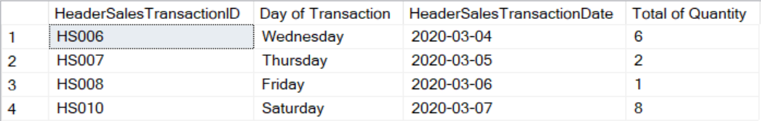

1. Add a **column** named ‘**CustomerInstagram’** on **Customer** table with **varchar (20)** data type and add a **constraint** named ‘**CheckInstagram’** to check the **CustomerInstagram** must **starts with** ‘@’.

(**alter table, add, add constraint**)

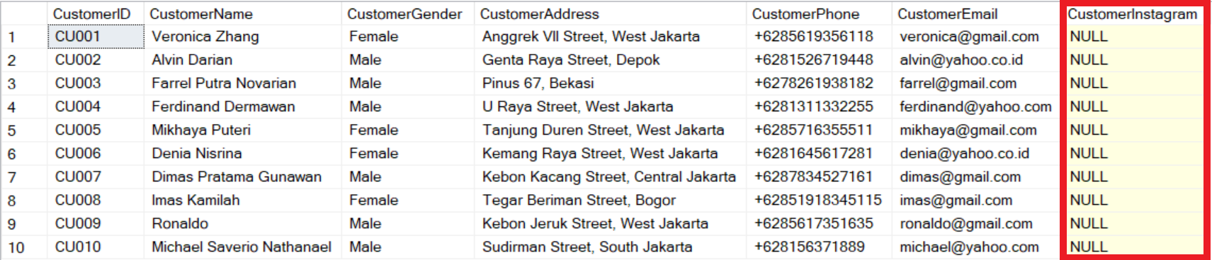

1. **Delete** from **Album** table data for every album which **price less than 350000** and **album name** contains **at least three words.**

(**delete, like**)

**Before:**

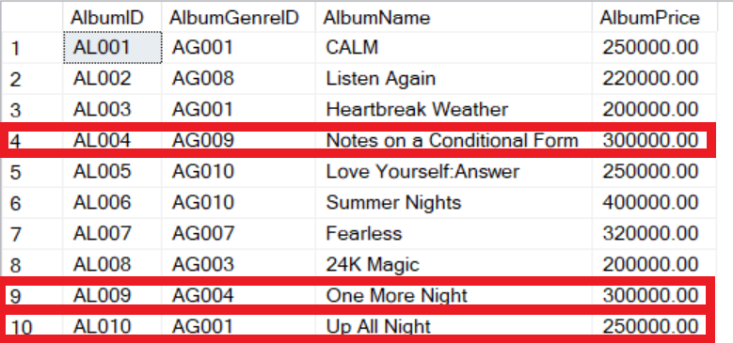

**After:**

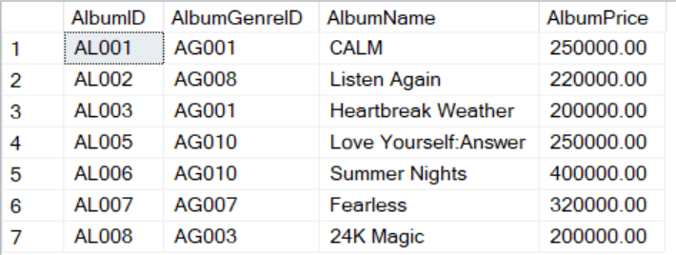

**For question regarding this exam, feel free to ask your teaching assistant!**

**Good Luck 😊**